Using End Point Detection When Wet Processing Compound Semiconductor Substrates
Craig Meuchel
Classone Technology, Inc., Technology Development Center, 3165 U.S. 93 South, Kalispell MT 59901
E-mail: cmeuchel@classone.com, Tel +1 406 253 6919

Keywords: wet etch, end point detection

ABSTRACT
It is common to utilize wet chemical etching in the process of manufacturing of compound semiconductor circuits. By improving linewidth control during this wet chemical-based processing (minimizing the distribution of line width), device yield will increase. By increasing line width control, wafer scrap due to loss of linewidth control will be reduced. Certain wet etch steps are required in the production of III-V and II-VI devices. Although time and temperature are easier to control, composition of the etchant and etched film thickness variation can both affect the wafer-to-wafer critical dimension control. One technique that can be applied is optical end point detection. This paper will discuss theory and actual application of end point detection in single wafer wet etch processing.
INTRODUCTION
Patterned gold plating is a common metallization scheme used in III-V mixed signal integrated circuits. A seed layer of gold is deposited by evaporation. The wafer is then patterned with photoresist and gold is electroplated on top of the exposed seed layer. The photoresist is stripped then the gold seed layer is etched using a KI/I2 based etchant. This etch step is critical to controlling the final dimension of the gold feature. As this etch has no mask, 100% of the surface of exposed gold is etched during the process. It is critical to stop the etch after gold seed is removed and before too much electroplated gold is etched. If gold seed is left behind, electrical contact will be made between adjacent lines. If too much gold is removed, device performance will suffer.
Critical parameters include time of etch, etchant temperature, flow rate (spray technology) and concentration of the chemical constituents. Normally, the concentration of the chemistry will change over time and shift the etch rate. As the bath ages, if all other factors are held constant, etch rate will drop. Normally, the bath is dumped and repoured which brings the etch rate back to the previous level. If the bath is mixed inconsistently, dimensional control will be compromised. Theoretically, bath lifetime can be extended with the use of end point detection which will result in cost savings.
One technique that will improve the dimensional control of wet etching is end point detection (EPD). This technique has been used for years in the dry etching arena. By monitoring the dry etch plasma with a wavelength monitor, the end of the process can be calculated by monitoring the changing intensity of certain wavelengths of light. When wet etching gold with gold etchant, a visual change can be seen as the gold clears. Although this change can be seen macroscopically, it is difficult to produce consistent results when human judgment is involved. By replacing the human eye with a machine, consistent results are easy to achieve.
APPLICATION
In simplest terms, end point detection will look at a signal from the reflected light and when it reaches a certain threshold, the etch action will be stopped. In application, this approach will not produce optimum results. In most cases, a certain amount of over etch must be used to complete the etch step. While the optical signal shows removal of the film, an extended amount of etch time is required to remove 100% of the film. The next problem with using a simple threshold is there are variables that can trick the algorithm and produce less than desirable results.
With fast computing power, the algorithm used to determine end point can be enhanced. The example in this paper uses a several variables to improve the consistency of the end point detection.
One of the more important variables is the wavelength range that is sensitive to the film being etched. Another variable is the wavelength range that is reflected from the underlying film (titanium is typical with gold). As the etched film is being removed, the underlying film will start to reflect light that can be very useful for EPD. The two signals can be combined; dividing the increasing signal by the decreasing signal produces an overall improved signal. See Figure 1.

Fig.1 Wavelength signal from underlying film (increasing) divided by wavelength signal of etch film (decreasing) producing a stronger signal than either wavelength range alone.
As the signal increases or decreases, a preset threshold is crossed. After this point, the system switches to monitoring the 1st derivative. See Figure 2.

Fig. 2 Processed signal passes threshold; search for inflection of 1st derivative starts.

To improve the analysis, the 1st derivative of the changing film signal is analyzed. By monitoring the slope of signal, the determination of endpoint is made more robust. As the reflected film signal increases or decreases, monitoring the slope of the signal gives the system information needed to make the end point decision. See Figure 3.

Fig. 3 Processed signal and 1st derivative of processed signal.

Typically, the system is looking for a downward trend of the derivative. This indicates that the reflective signal is changing at a slower rate because the film of interest has been removed and the surface is not changing. When the specified condition of the slope is met, the system concludes that the endpoint has been achieved. At this point, the system goes into a timed over etch condition. See Figure 4.
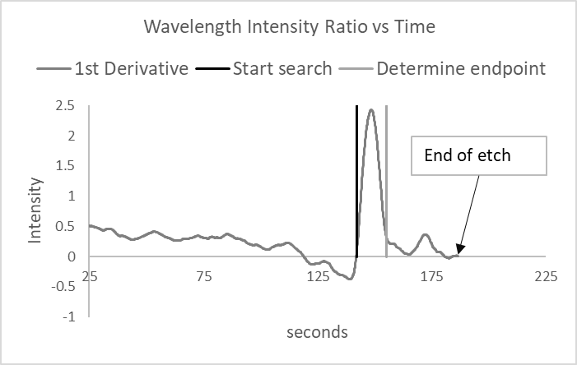
Fig. 4 Algorithm analyzes 1st derivative signal until end point is determined.
This over etch time is set as a percentage of the total etch time or a fixed time. Over etch (OE) is normally used to etch any remaining residue from the surface of the wafer. In a situation that uses a time based etch, the over etch will normally be too aggressive to cover a worst-case condition. With the addition of EPD, the over etch is based on data from the wafer which will improve the process.
SUMMARY AND CONCLUSIONS
Process end point detection is a useful addition to wet etch processing. By utilizing the capabilities of a readily available technology and applying to wet etching, process control will improve. The application of EPD will adjust the total etch time by analyzing the etch rate in real time. The influence of variables that affect etch rate can be negated (etchant temperature, flow rate, film thickness, and chemical concentration). Another advantage is the over etch time can be reduced which will lower the amount of undercut found in seed layer etching (seed layer is a different material than the patterned film).
ACKNOWLEDGEMENTS
The author would like to thank Frank Mendoza of Verity Instruments for various discussions regarding optimization of the algorithms used in this paper.
ACRONYMS
EPD: End Point Detection
OE: Over Etch

